**Exercise 1: Configuring a Basic Spring Application**

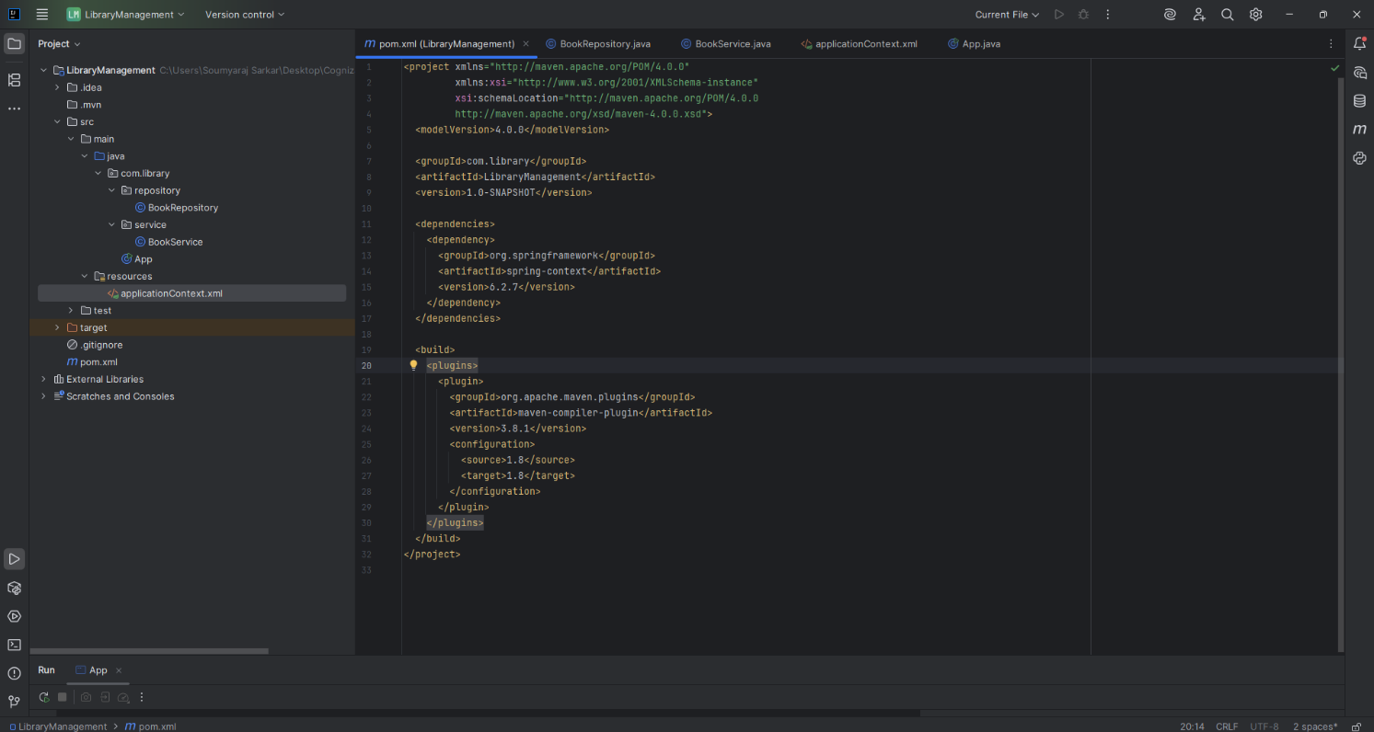Adding Spring Core dependencies in the **pom.xml** file

Created an XML configuration file named **applicationContext.xml** in the **src/main /resources** directory.

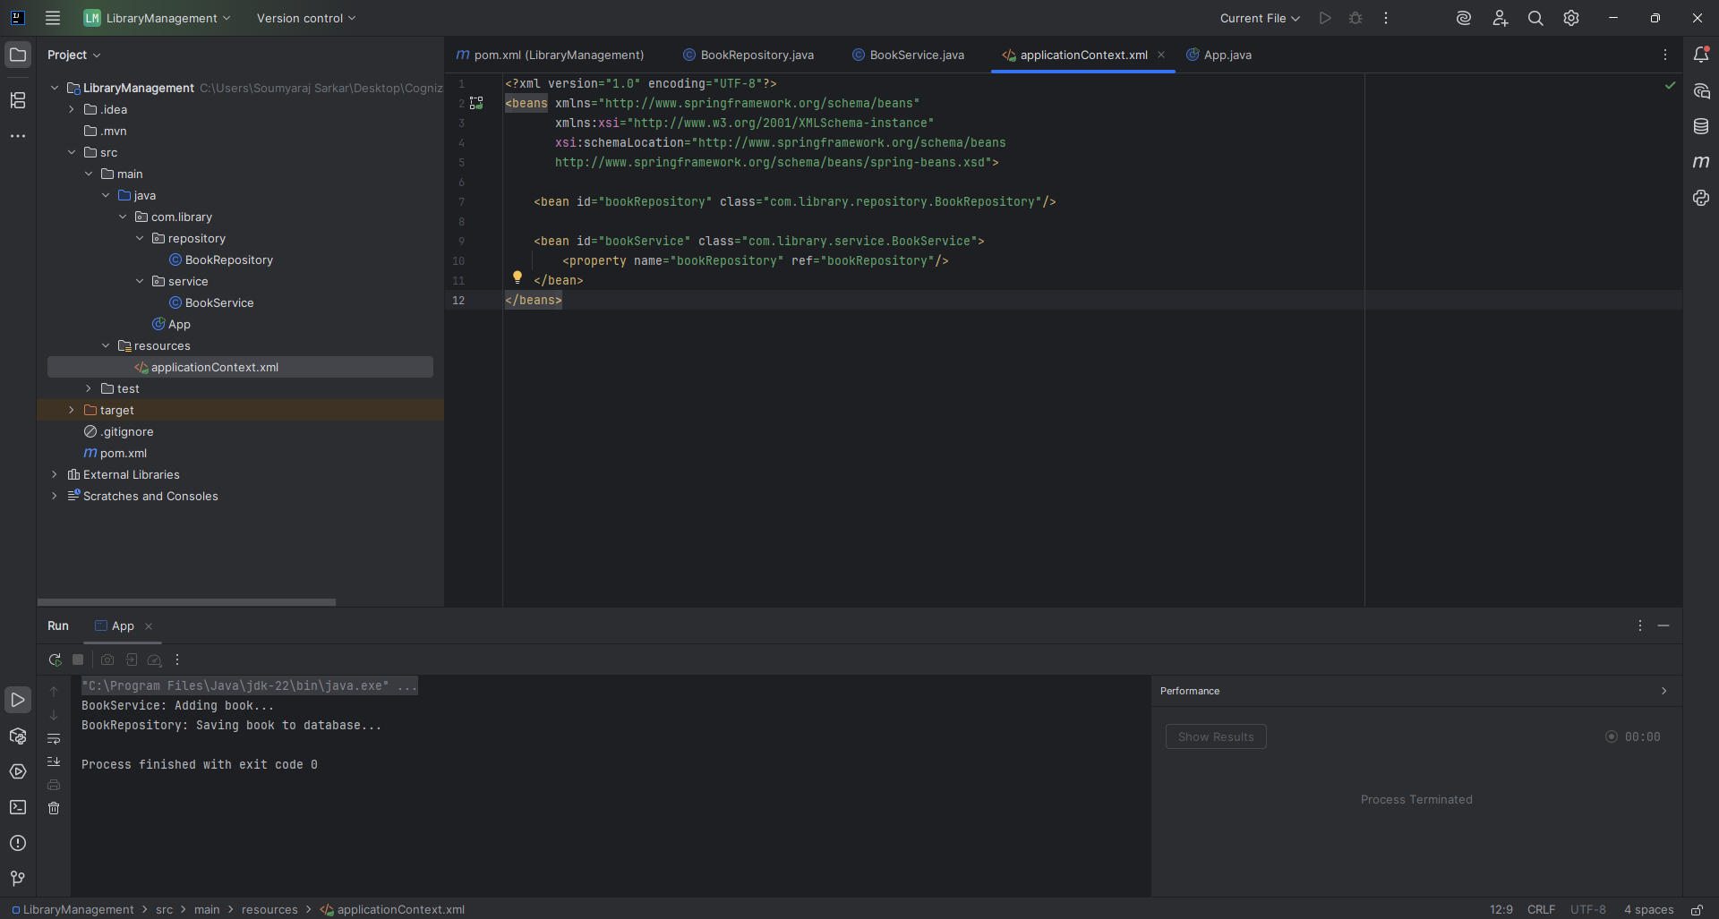

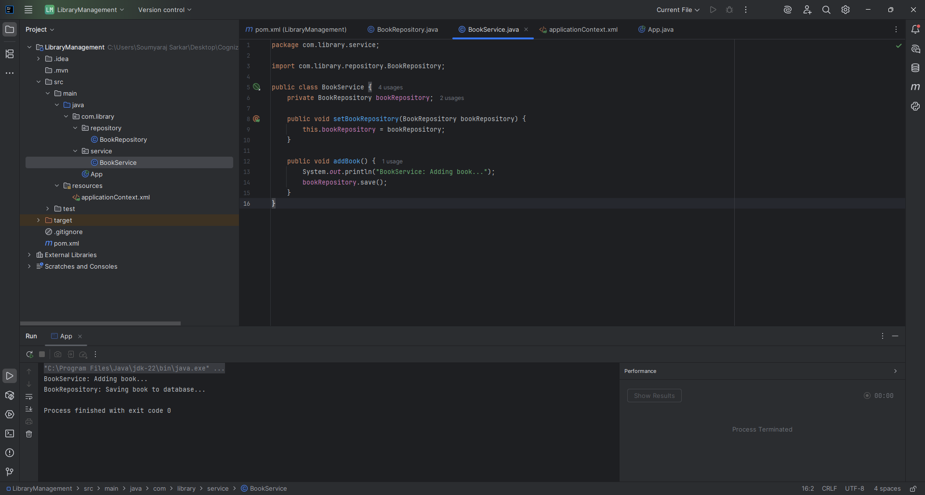Created a package **com.library.service** and add a class **BookService.**

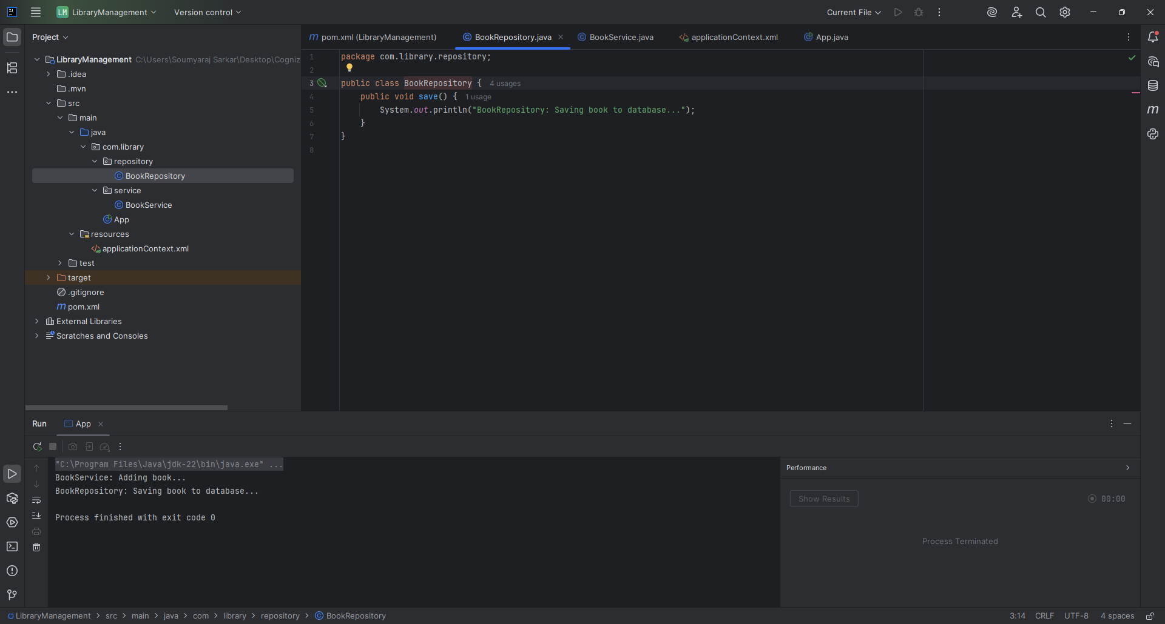Created a package **com.library.repository** and add a class **BookRepository**.

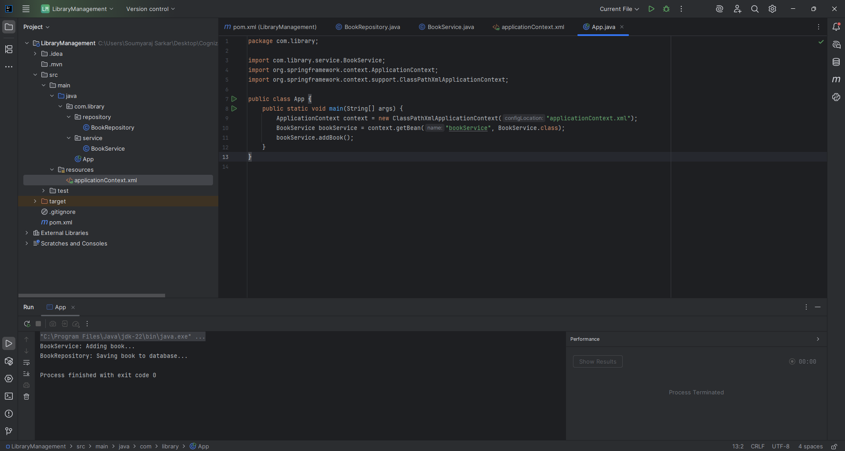Created a main class to load the Spring context and test the configuration.

Output:

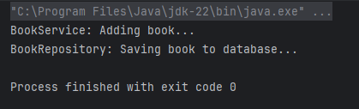

**Exercise 2: Implementing Dependency Injection**

Modified the XML Configuration:

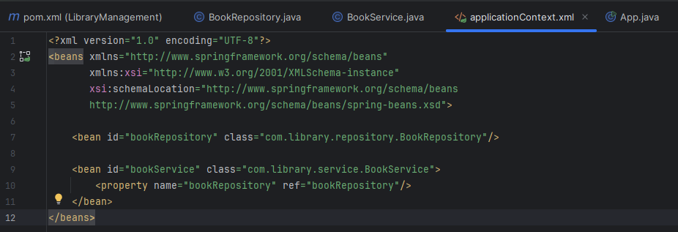

Updated the BookService Class:

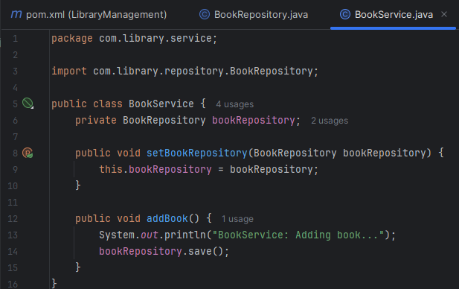

Output:

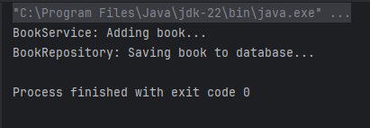

**Exercise 4: Creating and Configuring a Maven Project**

Created a new Maven project named LibraryManagement.

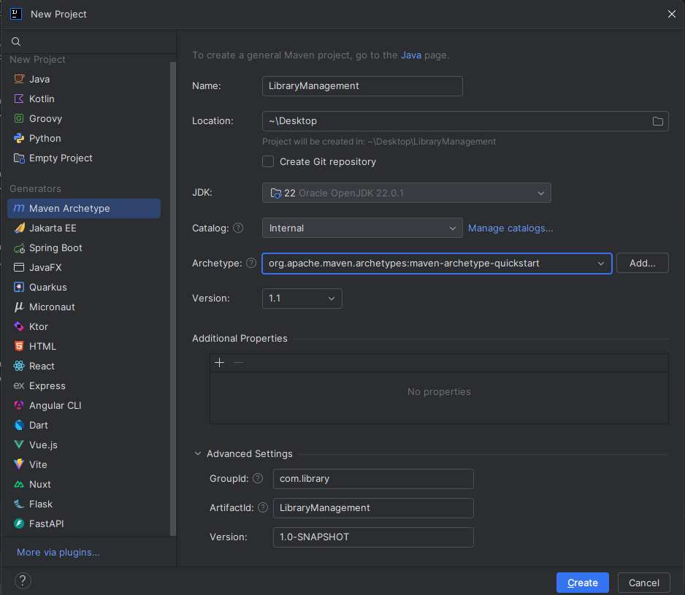

Included dependencies for Spring Context, Spring AOP, and Spring WebMVC:

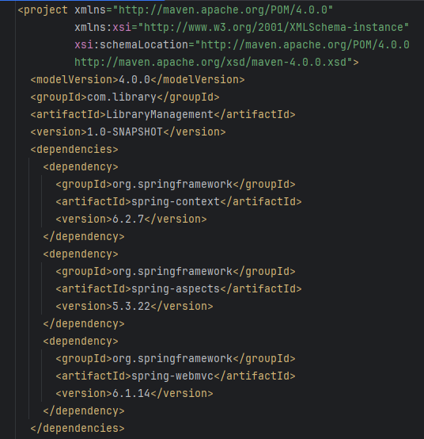

Configured the Maven Compiler Plugin for Java version 1.8 in the pom.xml file:

